WELCOME!

Thank you for signing up to ride the Parkinson’s Revolution. Now it’s time to clip-in and gear up to make lives better for people living with Parkinson’s. Before the ride, you will have plenty of opportunities to share your story, invite friends and family to join you and raise awareness.

Everyone’s reason for riding is different. For one day we will ride together with one common goal: to get us closer to a world without Parkinson’s.

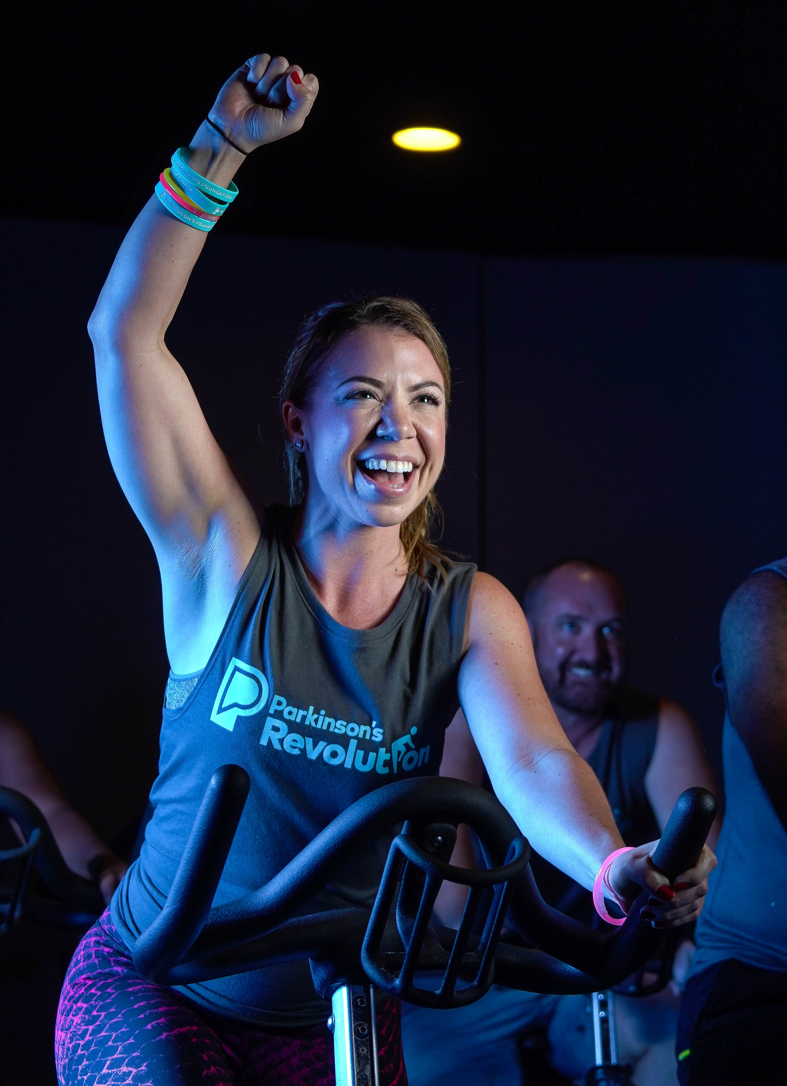
Three quick ways to get started:

- Set Your Fundraising Goal. Create a goal that is a bit of a stretch for you. Your social community can have fun helping you and cheering you on!

- Think about how you want to fundraise. Reaching friends and family though email tends to have the most consistent results. Social media is a wonderful tool for sharing your story. Also, think of creative, fun ways you can fundraise out in your community.

- Make a List. Create a list of friends, family, coworkers, local community leaders and friends from the gym. Every 9 minutes someone is diagnosed with Parkinson’s so you never know who has a connection to PD. Plus, people can’t say yes if you don’t ask.

Remember your reason for riding. Every dollar you raise brings us closer to a world without Parkinson’s. As you gear up to ride the Revolution, we want you to know we’re here for you!

The Movement Begins With You!

GET STARTED NOW!

Table of Contents
How to Use This Toolkit 3
Fundraising Email Templates 4
Fundraising Text Messages 11
Social Media Messages 12
Follow Up and Thanking Your Donors 13

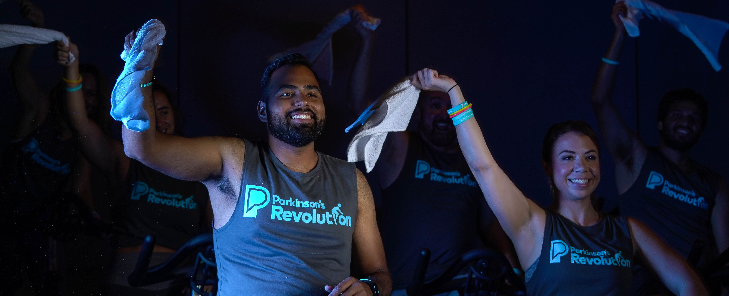

How to Use This Toolkit

Best Practices
This toolkit provides support and fundraising guidance for Parkinson’s Revolution riders. It includes a series of emails, texts, social media content and fundraising ideas.
- Use our templates. Copy and paste our pre-written templates OR use them as a guide. You can highlight the text below and paste it into your email.

- Personalize each message. Consider using photos, videos and graphics to tell your story. Videos and picture show up in more people’s newsfeed on Facebook so get creative with your storytelling.

- Ask individually. Personalized emails and texts mean a lot! If you text and email different people once a day for a week, the results will amaze you.

- Send emails to your entire list throughout your journey. Even if they have already donated, your supporters love to hear updates.

- Follow up. Not everyone responds the first time.

- Keep moving if you get a no. There are more people out there ready to participate. It’s not personal.

- Stay inspired. What you’re doing is special. Your goal is within reach. Remember your story.

Fundraising Email Templates
Email: Announcement / Invitation to Give

Subject: BIG NEWS – I joined the Parkinson’s Revolution!

Hey Friends,

Big News! I’m hopping on a spin bike and cycling to raise money and awareness in Parkinson’s Revolution, an indoor cycling event that benefits the Parkinson’s Foundation. I’m excited to support groundbreaking research while breaking a sweat.

On Saturday, DATE, I will ride for one reason: to beat Parkinson’s.

I would love for you to join me [insert link] and ride OR cheer me on and donate to help fund their mission to make lives better for people living with Parkinson’s. This mission means a lot to me because [insert personal connection or passion]

My goal is to raise $ [insert donation goal]. Every dollar I raise will go toward improving care and advancing research toward a cure. All you have to do is click here [insert link] to make a donation today.

Follow along with me as I work toward my fundraising goal ― I’ll send out emails (and post on Facebook and Instagram).

Thank you in advance for your help. It’s great to know that I have a strong support system cheering me on!

All the best!
Your Name

Email: About Parkinson’s Foundation

Subject: Will you support my Parkinson’s Revolution?

Hello!

Big changes are caused by small actions that add up. I have already begun to see this change build as a Parkinson’s Revolution rider. I have raised $X which is X% of my goal. I am excited to see my friends and family help me support the Parkinson’s Foundation mission to improve care and advance research towards a cure.

Did you know your donation helps support resources like the Parkinson’s Foundation Centers of Excellence? These are medical centers with a specialized team of neurologists, movement disorder specialists and may others who provide the best Parkinson’s care. Combined, the 47 centers in the network provide care to more than 145,000 people with PD.

If you would like to help me support these vital community programs and bringing expert care to more people with Parkinson’s, visit [insert link] and donate today.

Follow me on social media for more updates [insert your social media handle].

Thank You!
Your Name

Email:

Subject: Getting Ready to Pedal for Parkinson’s

Hi!

I want to thank you for all the kind words, donations and suggestions that have helped me fundraise for my Parkinson’s Revolution ride. We are only X weeks away and have already raised $X.

Your love and support have been such driving forces in all my training and preparation for the big day! There is no doubt that we are making lives better, together, by raising funds for the Parkinson’s Foundation.

Still looking for ways to help? Please forward or share any of my emails, texts or social posts to friends who might want to support.

You can also still sign up to ride and partner with me for Parkinson’s Revolution. Visit Parkinson.org/Revolution.

Remember to donate, all you have do is click here [insert link].

Thank you!
Your Name

Email: Training and Fundraising Milestone

Subject: I am in it to SPIN IT for Parkinson’s!

I’ve been in and out of spin class all month preparing for my Parkinson’s Revolution ride. Each class I push myself harder to get ready for the the big day!

Together, we have raised $X for the Parkinson’s Foundation. These funds help people living with Parkinson’s across the country and locally through their Community Grant program. Thanks to donors like you, the Parkinson’s Foundation gave away over $2 million last year to local fitness programs, voice and art classes, and more. I’m so proud to be a part of the effort to raise even more money this year.

Helping the Parkinson’s Foundation means a lot to me because [insert personal connection or reason for riding]. If you are interested in donating, joining the ride or offering your support in other ways, please click here [insert link].

Thank you!
Your Name

Email: Last Call (1 week before event day)

Subject: It’s Go Time!

I can’t believe the Parkinson’s Revolution is only one week away! I am ready to kick it into gear and ride for a challenging [90/45] minutes to support Parkinson’s research.

Thank you for cheering me on as I train and fundraise for a cause that means so much to me. I have felt the support with all your inspiring texts, emails and comments on social media. I am dedicated to riding strong and making you proud.

Thanks to your generous support, I’m happy to report that we have raised $X.

Is there still time to donate? Can you donate again? Can your company match your donation? The answer is YES! CLICK HERE [insert link]. Any amount is appreciated.

Follow along on Instagram and Facebook as I post updates throughout the week.

All the best!
Your Name

Email: Day of Revolution Ride

Subject: YOU helped me succeed!

It’s official! Parkinson’s Revolution was an amazing event and I had a wonderful ride. The inspiration from my family and friends really kept me moving.

Thank you so much for following along with me! We raised a total of $X to improve care and advance research towards a cure for Parkinson’s disease.

There are no words to say how much I appreciate your support. You helped me exceed my goals and finish strong.

Many Thanks,
Your Name

P.S. If you still want to donate to Parkinson’s Revolution, I would greatly appreciate it. Visit my page [insert link].

For more information about Parkinson’s Revolution and other events visit Parkinson.org/Events.

Email: Thank You (Individual Message)

Subject: Thank You for Supporting Parkinson’s Research!

Dear Name,

Thank you so much for your amazing support! I saw your donation of $X in support of my Parkinson’s Revolution ride. I will make you proud as I ride in the event. I appreciate your generosity.

Your donation not only supports me ― it will help improve care and advance research towards a cure for Parkinson’s disease.

Have a great day!
Your Name

Email: Thank You (Individual Message for those riding in honor/in memory)

Subject: Your Support Means So Much!

Dear Name,

Thank You! I noticed your kind donation in support of the Parkinson’s Foundation and my participation in Parkinson’s Revolution.

You are so gracious and thoughtful to believe in me and honor my [share your reason for riding]. It makes me so proud to give back in this meaningful way. I will ride for you!

Thank you again for your support!

Best,
Your Name

Fundraising Text Messages

Text: After registration

Hey ___ !
Exciting news! I’ve joined the Parkinson’s Revolution ― an indoor cycling event to support the Parkinson’s Foundation. If you’re interested in donating, I would appreciate any support (big or small!) Click the link to learn more, join me and donate. [insert link] Thank you!

Text: Week before event

It’s time to ride! It is Parkinson’s Revolution week! If you haven’t had a chance to donate yet, here’s a link. Any amount makes a difference, and I can’t begin to thank you for the love and support. Click the link to learn more and donate. [insert link]

Text: Reminder.

Just a reminder ― Parkinson’s Revolution Ride is this weekend! I’ll be cycling for a great cause and would love your support with positive energy, good vibes and a donation is always welcome! Click the link to learn to donate. [insert link]

Text: Post Event

I did it! Thank you for helping me support Parkinson’s research through Parkinson’s Revolution. It was so fun! I hope you can join me next year. If you still haven’t had a chance to donate, just click below on my personal page. [insert link]

Social Media Messages

Social Media: Announcement of Parkinson’s Revolution
I am officially part of Parkinson’s Revolution! I’m so excited to clip in, turn up the resistance and pedal for such a great cause. Parkinson’s Revolution is a fun indoor cycling event where riders raise funds to benefit Parkinson’s. Find out how you can partner with me on this journey and support a great cause too! Click on the link in my Bio to support me. [insert link]

Social Media: Did you Know?
Did you Know?
Every 9 minutes someone is diagnosed with Parkinson’s disease. On DATE I am riding for 90 minutes to generate awareness and fundraise for the Parkinson’s Foundation.

I am excited as this will be a memorable, inspiring and a powerful day of celebration and hope.

Please join me and support the Parkinson’s Foundation. Visit my personal fundraising page [Insert Link]

Social Media: I’m Ready to Ride!
I’m ready!

Parkinson’s Revolution is only a few weeks away! This experience has already brought me closer to my mission of making life better for people with Parkinson’s.

Make a difference today and help me reach my fundraising goal. Whether its $5 or $50, your support does not go unnoticed! Click the link in my bio to donate.

Social Media: Fundraising Update and Thank You! (Tip: personalize and tag your supporters)

#Gratitude for all of you who have helped me reach my goal of $X raised to support @ParkinsonDotOrg. A special thank you to @XXXX (Tag all people who gave). So far, I raised $X. I am almost there and would love your support. Click below to show the love for Parkinson’s research. [Insert Link]

Follow Up and Thanking Your Donors

Social: How Parkinson’s Revolution Helps

Many of you have asked how the Parkinson’s Foundation supports the Parkinson’s community. Here are a few ways:

Research: Annual grants to early-career scientists who launch research initiatives exploring new Parkinson’s treatments and medications, while leading us toward a cure.

Expert Care: With a network of 51 incredible centers across the country, the Parkinson’s Foundation Centers of Excellence provide expert Parkinson’s from movement disorder specialists to speech therapists – for more than 145,000 people living with PD.

Advocacy: The Parkinson’s Foundation works with policy makers on the local, state and national levels to ensure the needs of people with Parkinson’s Foundation are met.

You can join me at the Parkinson’s Revolution ride on DATE or donate to help me meet my fundraising goal. The great work at the Parkinson’s Foundation can only continue with support from people like you and me. Click Below to Donate. [Insert Link]

Social Media: Event Day (Tip: Post your event-day outfit.)

The Parkinson’s Revolution Ride is finally here! Getting ready to give my pedals purpose with @ParkinsonDotOrg. Your support will push me along throughout the ride. Follow along today for updates!

There’s still time to give a donation in honor of my ride today. Again, I cannot thank you all enough for all your support. Wish me luck!

Social: Thank you
Hint: Speak from the heart and tag your supporters. Check out the samples below.

Thank You! I thought about my incredible support system today as I cycled for the Parkinson’s Revolution, and I am truly blessed to have you all in my life. The ride was great and the energy was electric.

So inspired and grateful for the support, donations and cheers I’ve received on this journey! We have raised a total of $X for @parkinsondotorg, and there’s still a little time left to give.

Thank You!

Congratulations!

You completed your Parkinson’s Revolution fundraiser. Thank you so much for the great work and for taking part in our event. We could not have done it without you.

Hope to see you next year!

Sincerely,
Your friends at the Parkinson’s Foundation
